EXP26.CREATE A SQL STORAGE SERVICE AND PERFORM A BASIC QUERY USINGANY PUBLIC CLOUD SERVICE PROVIDER (AZURE/GCP/AWS) TO DEMONSTRATE DATABASE AS A SERVICE (DAAS)

AIM:
Create A SQL Storage Service and Perform A Basic Query Using any Public Cloud Service Provider (Azure/Gcp/Aws) To Demonstrate Database as a Service (DAAS)
PROCEDURE:
STEP1: GOTO AZURE AND GOTO SQLDATABASE.
STEP 02: Now Create a Sql Databse
STEP3: SELECT THE RESOURCE GROUPAND ENTER THE SERVERNAMETHATAPPLICABLE.
STEP4: IN NETWORKING SELECT ALLOW AZURE SERVICES AND
RESOURCES TO ACCESS THIS SERVER.
STEP5: IN ADDITIONAL SETTINGS SELECT SAMPLE.
STEP6:AND THE SQL DATABASE IS DEPLOYED
TEP7: NOW GOTO QUERY EDITOR.
STEP8: NOW AGAIN LOGIN TO THE SQLDATADATABASE
STEP9: OUR TABLES WILL SHOWN AND TYPE THE QUERY TO EXCUTED.

IMPLEMENTATION:
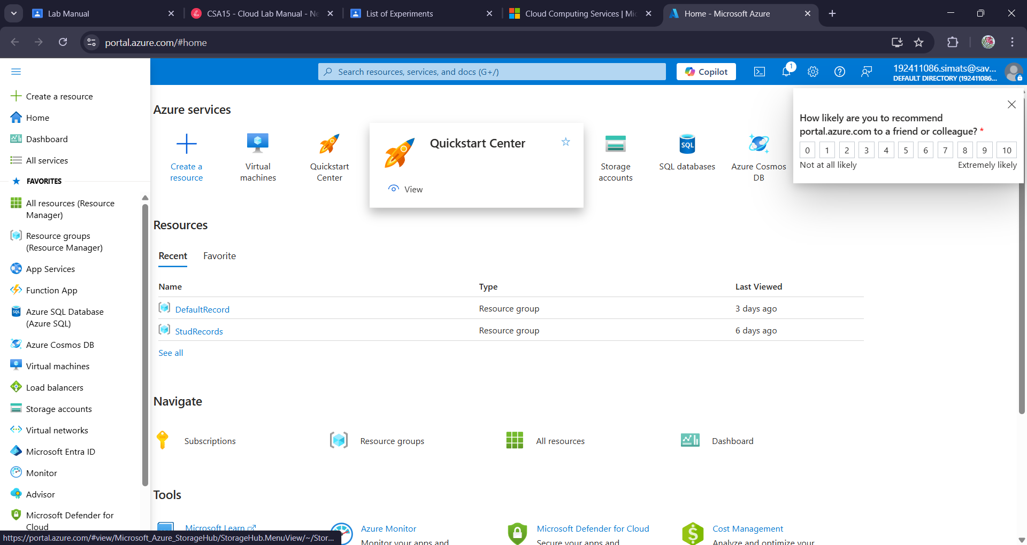

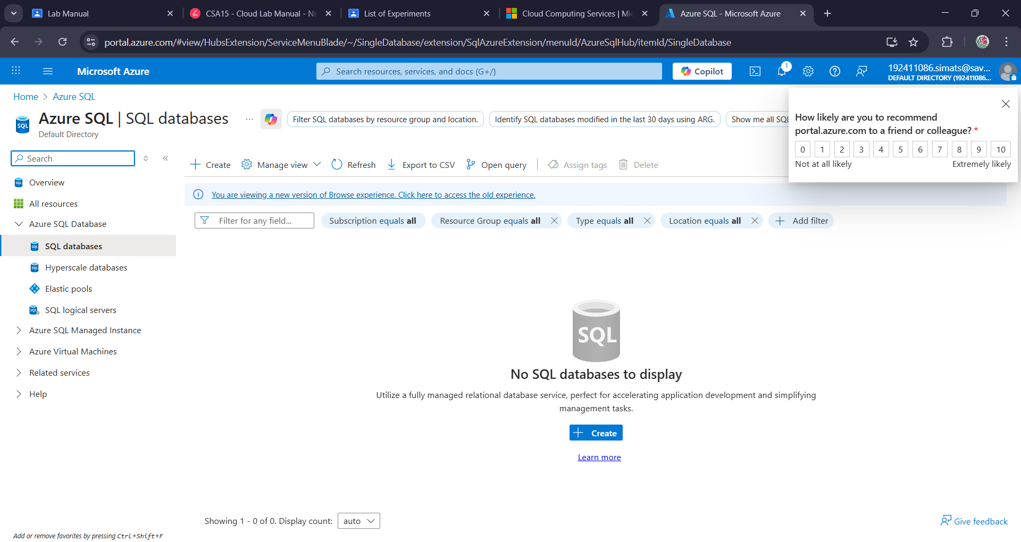
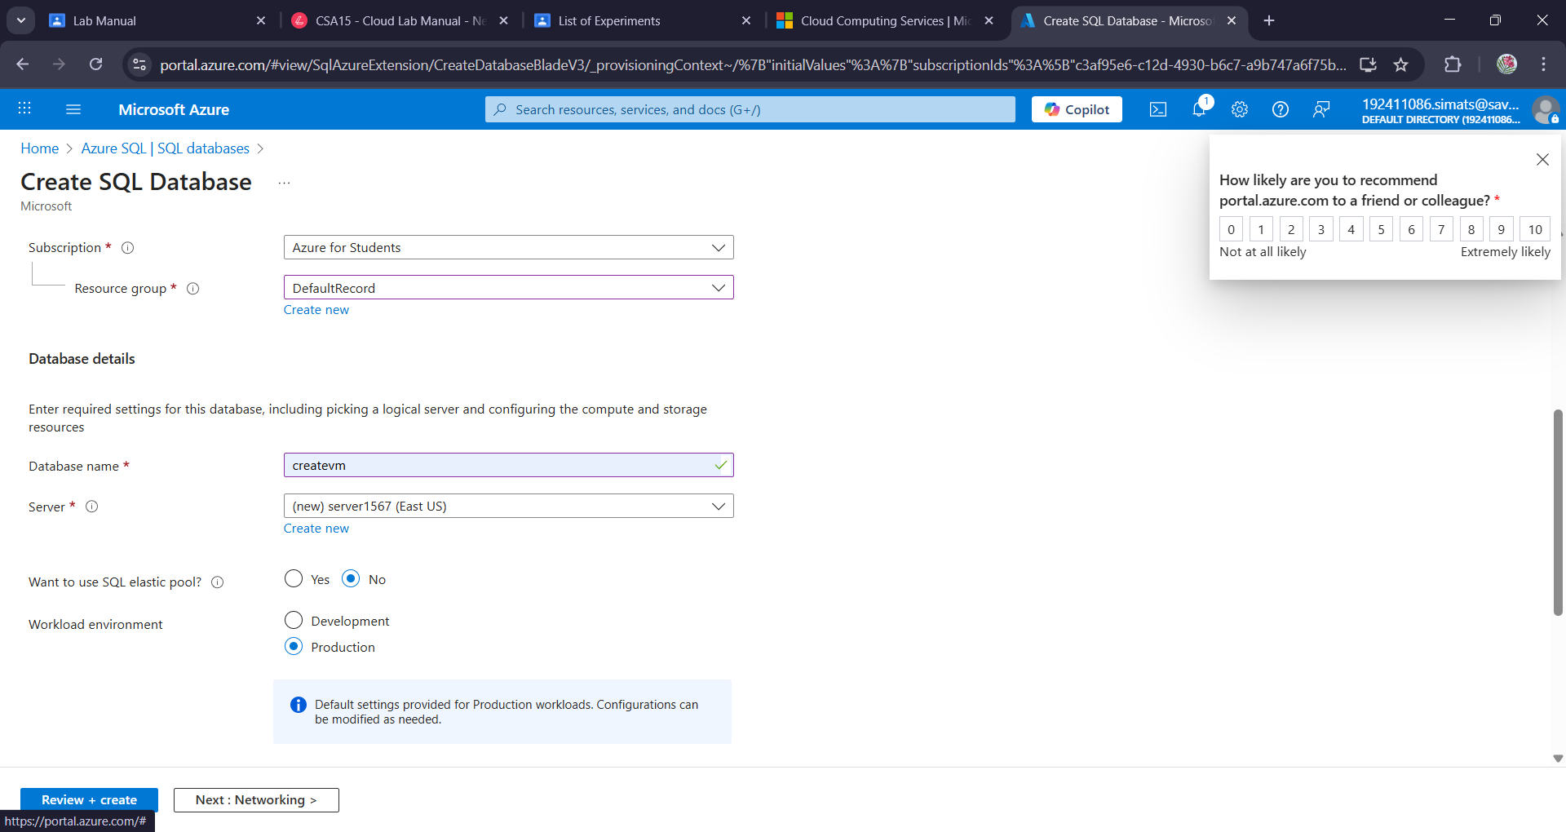

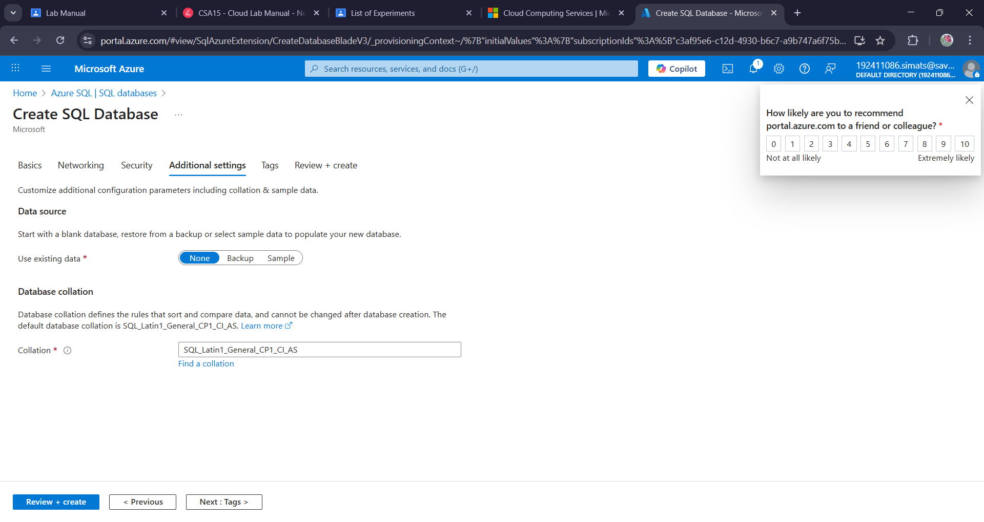

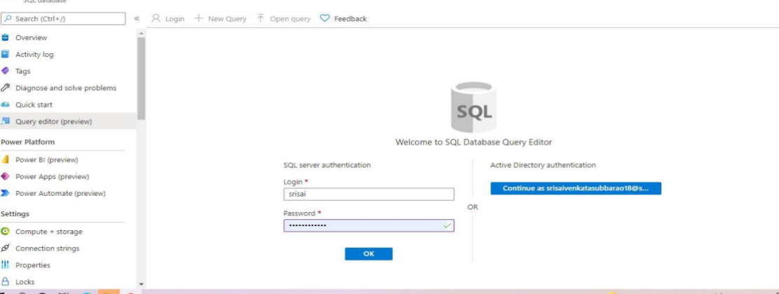

Result:
A SQL storage service and perform a basic query using any public cloud service provider (azure/gcp/aws) to demonstrate database as a service (daas) has been created.

